
FRESH TEACHER'S E-LIBRARY
BEGINNING OF TERM III EXAMINATION 2023
PRIMARY TWO
ENGLISH

My name is __________________________________________

I am in ______________________________________________

My school is _________________________________________
SECTION A:
- Fill in the missing letters.
- fe____ry (b) bi_____ycle (c) nu____se
- Fill in the gaps with the correct word.
- January __________________the first month of the year.
- The name of my school is ___________________________
- It is the work of the school nurse to treat_______________ pupils.
- I use my ______________________to write in my book.
- The baby is ___________________because he is hungry.
- Arrange the words in alphabetical order.
- hospital, school, church, mosque.
______________________________________________________
- goat, cow, sheep, hen
______________________________________________________
- Use “have” or “ has” to complete the sentences.
- She ________________an apple and a cake.
- The boys ____________________new balls in their bags.
- Ken __________________________a new pair of shoes.
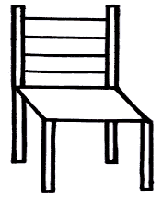
- Use ‘near’, ‘in’, or under to fill in the blank spaces.
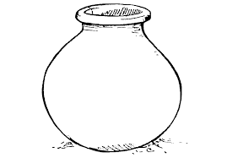
- The pot is _______________the chair.

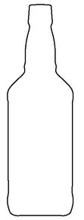

- The milk is ________________the bottle.

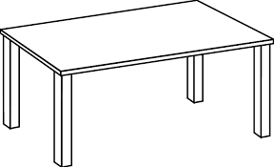
- The cat is ___________________the table.
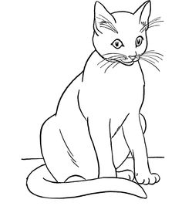

- Use the correct form of the words in the brackets correctly.
- Juliet ____________her school uniform every day. (wash)
- Your bag is ________________________than mine. (big)
- Nakato lost ______________________new pencil. (she)
- How many _____________are in the classroom? (bench)
- Aaron is the ___________________boy in our class. (small)
- Rewrite the sentences as instructed in the brackets.
- That is the teacher. He lost his phone.
(use ………………….who………………..…..)
______________________________________________________
- The boys are clever. The girls are clever.
(Use:……………..…..and …………………….)
______________________________________________________
- She is eating food. (Begin: They…………………………)
______________________________________________________
- He plays football on Monday. (Begin: He doesn’t ……..)
______________________________________________________
- Jerry did not write. He did not have a pencil.
(Use:…………..because………………….)
______________________________________________________
SECTION B
- Read the story and answer questions about in full sentences.
Last Thursday, when Mr. Musoke was driving a lorry, he was stopped by a policeman. His lorry was over loaded with matooke and it was in poor condition. The policeman told him to come out of the lorry.
He was arrested and taken to the police station. There, he was told to pay ten thousand shillings. The police woman told her to go back home and rest. Mr. Musoke left his lorry and keys at the police station where he picked them the next day on Friday.
Question.
- What is the name of the driver?
________________________________________________________
- What was the lorry carrying?
________________________________________________________
- Who arrested Mr. Musoke?
________________________________________________________
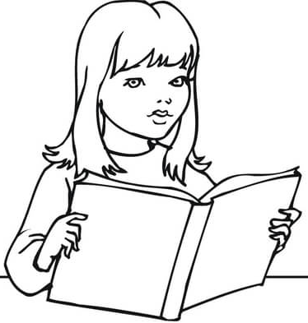
- Mr. Musoke left his lorry and ________________at the police station.
- Use the pictures to fill in the gaps correctly.
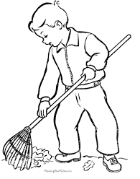
- Liz is _________________________a book.

- The boy is ________________________the compound.
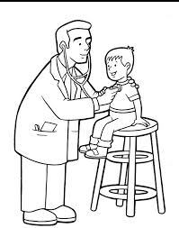
- The doctor is ________________________a sick boy.
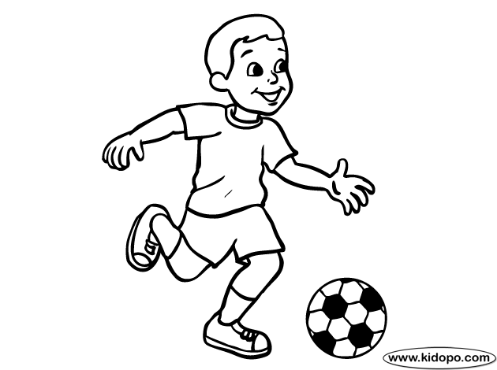
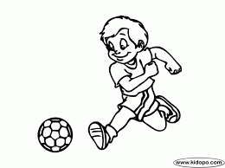

- Joel and Peter are __________________with a ball.
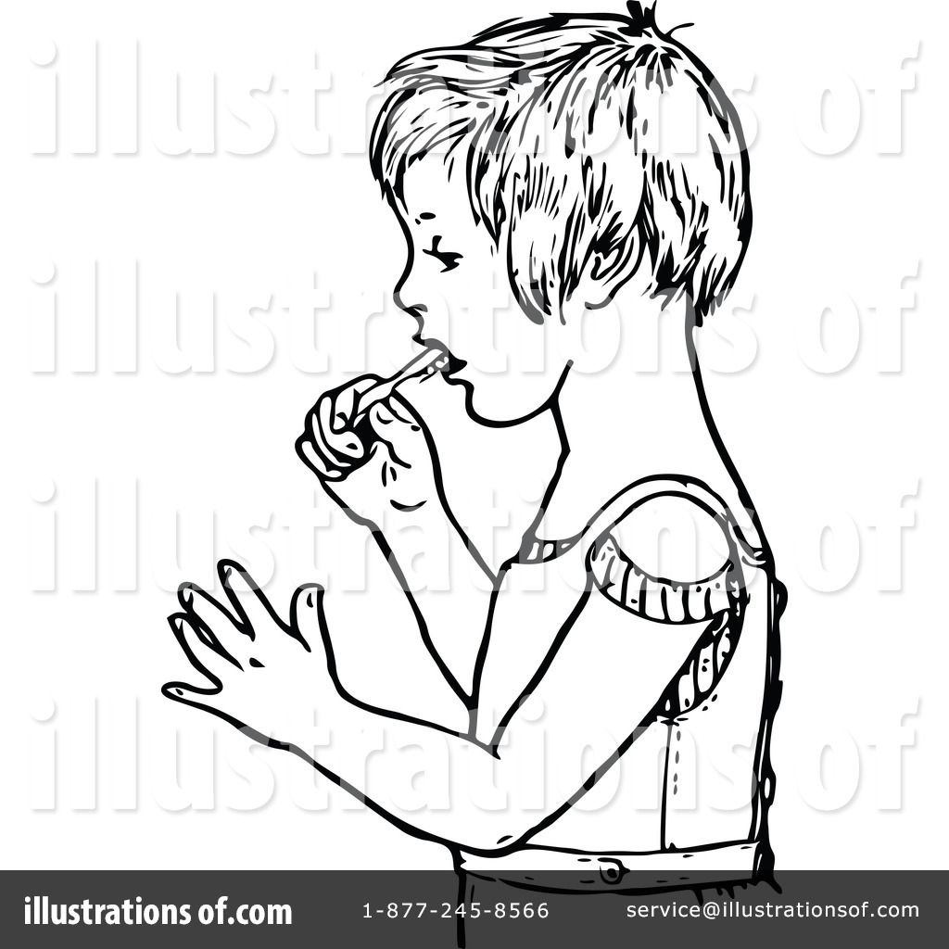

- The girl is _____________________her teeth.
- Use the words to fill in the gaps in the story.
Bean seeds are ____________to grow. First, you get an___________tin, put in soil and water. Then put in the seeds and keep _____________ them. After three days, the bean seeds will ______________________. After two months, _______________will produce beans that you can
harvest.

they, watering, germinate, empty, easy
- Re – arrange the sentences below to form a good story.
- The biggest animal of all was the elephant.
- At the zoo, we saw many animals.
- This elephant had large ears and a small tail.
- Last year, my class visited the zoo.
- Some of them were big and others were small.
- ________________________________________________________
- ________________________________________________________
- ________________________________________________________
- ________________________________________________________
- ___________________________________________________________
- Write one word for the underlined group of words.
- A person who drives a car must be careful.
______________________________________________________
- The man who treats sick people is ever smart.
______________________________________________________
- The young dog is in the kennel.
______________________________________________________
- Match correctly.
A donkey is  Most insects  There is  Sarah can  Mosquitoes | wash her uniform.  spread malaria.  used for transport.  have wings used for flying.  some milk in the flask.
************END***********

